Write a code to print the numbers in the array

**Output**: 1234567891011

var numsArr = [ 1, 2, 3, 4, 5, 6, 7, 8, 9, 10, 11];var new_string = “”;  
   
for (var i = 1; i < 11; i--) {  
 new_string += numsArr[i]   
}console.log(new_string);

CODE:

 var numsArr = [ 1, 2, 3, 4, 5, 6, 7, 8, 9, 10, 11];

 var new_string = "";

 for (var i = 0; i < 11; i++) {

  new_string += numsArr[i]

 }

 console.log(new_string);

OUTPUT:

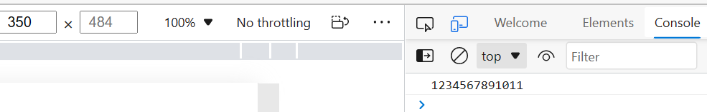

Write a code to print the numbers in the array

**Output**: 1,2,3,4,5,6,7,8,9,10,11

var numsArr = [ 1, 2, 3, 4, 5, 6, 7, 8, 9, 10, 11];var new_string = “”;  
   
for (var i = 1; i < 11; i++) {  
 new_string += numsArr[i] + ,   
}console.log(new_string);

CODE:

var numsArr = [ 1, 2, 3, 4, 5, 6, 7, 8, 9, 10, 11];

var new_string = "";

for (var i = 0; i < 11; i++) {

if(i==numsArr.length-1){

    new_string += numsArr[i]

}else{

    new_string += numsArr[i] + ",";

}

}

console.log(new_string);

OUTPUT:

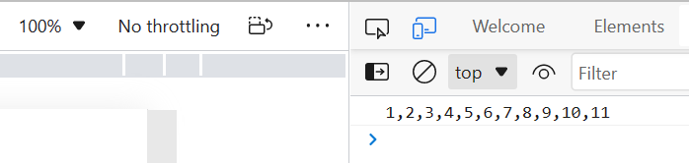

Write a code to print from last to first with spaces (Make sure there is no space after the last element 1)

**Output**: 11 10 9 8 7 6 5 4 3 2 1

var new_string = “”;  
   
for (var i = 11; i > 0; i — ) {  
 new_string += numsArr[i] + “ “   
}  
console.log(new_string);

CODE:

var numsArr = [ 1, 2, 3, 4, 5, 6, 7, 8, 9, 10, 11];

var new_string = "";

for (var i = numsArr.length-1; i >=0; i--) {

 new_string += numsArr[i] + " ";

}

console.log(new_string.trim());

OUTPUT:

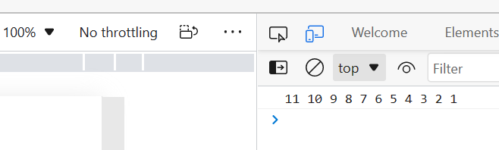

Write a code to replace the array value — If the number is even, replace it with ‘even’.

**Output**:[ 1, “even”, 3, “even”, 5, “even”, 7, “even”, 9, “even”, … ]

var numsArr = [ 1, 2, 3, 4, 5, 6, 7, 8, 9, 10, 11];for (var i = 0; i <=10; i++) {  
 if(numsArr[i] %2 == 0 )  
 {  
 numsArr[i] = odd  
 }  
}  
console.log(numsArr);

CODE:

var numsArr = [ 1, 2, 3, 4, 5, 6, 7, 8, 9, 10, 11];

for (var i = 0; i <=10; i++) {

 if(numsArr[i] %2 == 0 )

 {

 numsArr[i] = "even";

 }

}

console.log(numsArr);

OUTPUT:

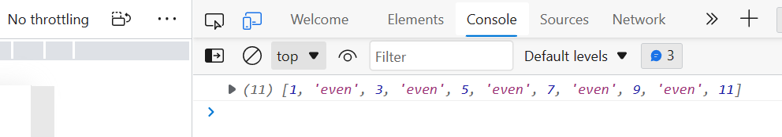

Write a code to replace the array value — If the index is even, replace it with ‘even’.

**Output**: [ “even”, 2, “even”, 4, “even”, 6, “even”, 8, “even”, 10, … ]

var numsArr = [ 1, 2, 3, 4, 5, 6, 7, 8, 9, 10, 11];for (var i = 0; i <=10; i++) {  
 if(numsArr[i] %2 == 0 )  
 {  
 numsArr[i] = even  
 }  
}  
console.log(numsArr);

CODE:

var numsArr = [ 1, 2, 3, 4, 5, 6, 7, 8, 9, 10, 11];

for (var i = 0; i <=10; i++) {

 if(i %2 === 0 )

 {

 numsArr[i] = "even";

 }

}

console.log(numsArr);

OUTPUT:

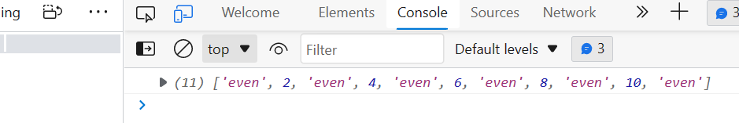

Write a code to add all the numbers in the array

Output: 66

var numsArr = [ 1, 2, 3, 4, 5, 6, 7, 8, 9, 10, 11];for (var i = 0; i <=10; i++) {  
 var sum;  
 sum += numsArr[i]  
}  
console.log(sum);

CODE:

var numsArr = [ 1, 2, 3, 4, 5, 6, 7, 8, 9, 10, 11];

var sum=0;

for (var i = 0; i <=10; i++) {

 sum += numsArr[i]

}

console.log(sum);

OUTPUT:

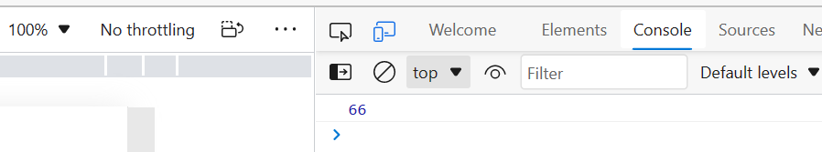

Write a code to add the even numbers only  
**Output**: 30

var numsArr = [ 1, 2, 3, 4, 5, 6, 7, 8, 9, 10, 11];  
var sum=0;for (var i = 0; i <10; i++) {  
 if(numsArr[i]%2==0);  
 sum += numsArr[i]  
}  
console.log(sum);

CODE:

var numsArr = [ 1, 2, 3, 4, 5, 6, 7, 8, 9, 10, 11];

var sum=0;

for (var i = 0; i <=10; i++) {

 if(numsArr[i]%2==0){

    sum += numsArr[i];

 }

}

console.log(sum);

OUTPUT:

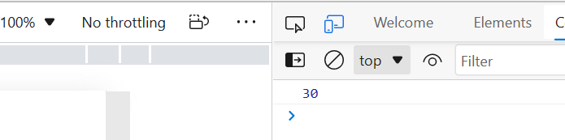

Write a code to add the even numbers and subract the odd numbers  
**Output**: 94

var numsArr = [ 1, 2, 3, 4, 5, 6, 7, 8, 9, 10, 11];  
var sum=100;for (var i = 0; i <=10; i++) {  
 if(numsArr[i]%2!=0);  
 {  
 sum += numsArr[i]  
 }  
 else  
 {  
 sum -= numsArr[i]  
 }  
}  
console.log(sum);

CODE:

var numsArr = [ 1, 2, 3, 4, 5, 6, 7, 8, 9, 10, 11];

var sum=100;

for (var i = 0; i <=10; i++) {

 if(numsArr[i]%2!=0)

 {

 sum -= numsArr[i]

 }

 else

 {

 sum += numsArr[i]

 }

}

console.log(sum);

OUTPUT:

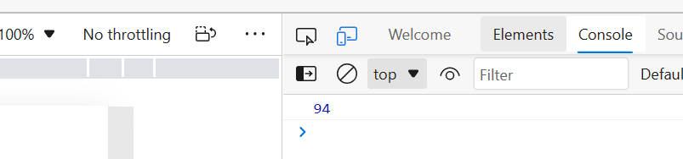

Write a code to print inner arrays  
**Output**:

Array(5) [ 1, 2, 3, 4, 5 ]  
Array(6) [ 6, 7, 8, 9, 10, 11 ]

var numsArr = [[1, 2, 3, 4, 5][ 6, 7, 8, 9, 10, 11]];  
for (var i = 0; i < numsArr.length; i++); {  
 console.log( numsArr[i])  
}

CODE:

var numsArr = [[1, 2, 3, 4, 5],[ 6, 7, 8, 9, 10, 11]];

for (var i = 0; i < numsArr.length; i++){

    console.log(numsArr[i]);

}

OUTPUT:

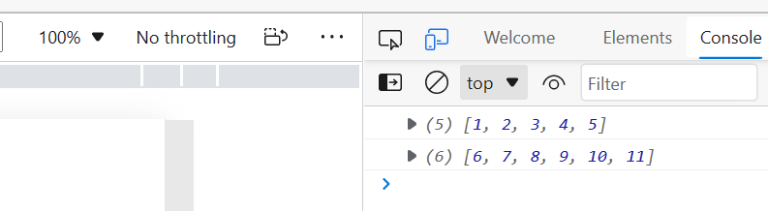

Write a code to print elements in the inner arrays  
**Output**: 1234567891011

var numsArr = [[1, 2, 3, 4, 5],[ 6, 7, 8, 9, 10, 11]];  
var str_all=0;for (var i = 0; i < numsArr.length; i++) {  
 var inner_array = numsArr[i];  
 for(var j = 0 ; j < inner_array.length;i++ )  
 str_all +=inner_array[j]  
}  
console.log(str_all);

CODE:

var numsArr = [[1, 2, 3, 4, 5],[ 6, 7, 8, 9, 10, 11]];

var str_all="";

for (var i = 0; i < numsArr.length; i++) {

 var inner_array = numsArr[i];

 for(var j = 0 ; j < inner_array.length;j++ ){

    str_all +=inner_array[j]

 }

}

console.log(str_all);

OUTPUT:

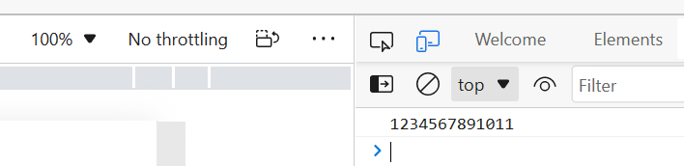

Write a code to replace the array value — If the index is even, replace it with ‘even’.

**Output**: [ [“even”, 2, “even”, 4, “even”], [6, “even”, 8, “even”, 10, …] ]

var numsArr = [[1, 2, 3, 4, 5],[ 6, 7, 8, 9, 10, 11]];  
var str_all=0;for (var i = 0; i < numsArr.length; i++) {  
 var inner_array = numsArr[i];  
 for(var j = 0 ; j < inner_array.length;i++ )  
 if(numsArr[i] %2 == 0 )  
 {  
 numsArr[i] = even  
 }  
}  
console.log(numsArr);

CODE:

var numsArr = [[1, 2, 3, 4, 5],[ 6, 7, 8, 9, 10, 11]];

var str_all=0;

for (var i = 0; i < numsArr.length; i++) {

 var inner_array = numsArr[i];

 for(var j = 0 ; j < inner_array.length;j++ ){

    if(str_all %2 == 0 )

    {

       inner_array[j] = "even";

     }

     str_all+=1;

 }

}

console.log(numsArr);

OUTPUT:

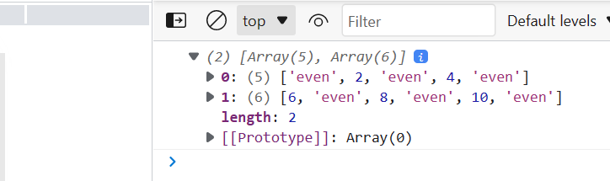

Write a code to print elements in the inner arrays in reverse  
**Output**: 11 10 9 8 7 6 5 4 3 2 1

var numsArr = [[1, 2, 3, 4, 5],[ 6, 7, 8, 9, 10, 11]];  
var str_all=0;for (var i = 0; i < numsArr.length; i++) {  
 var inner_array = numsArr[i];  
 for(var j = inner_array.length; j < 0 ;j-- )  
 str_all +=inner_array[j]  
}  
console.log(str_all);

CODE:

var numsArr = [[1, 2, 3, 4, 5],[ 6, 7, 8, 9, 10, 11]];

var str_all="";

for (var i = numsArr.length-1; i >=0; i--) {

 var inner_array = numsArr[i];

 for(var j = inner_array.length-1; j >= 0 ;j-- )

     str_all +=inner_array[j]+" "

}

console.log(str_all.trim());

OUTPUT:

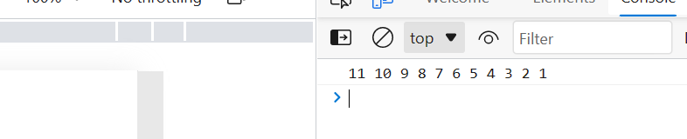

Write a code to add elements in the inner arrays based on odd or even values  
**Output**:  
36  
30

var numsArr = [[1, 2, 3, 4, 5],[ 6, 7, 8, 9, 10, 11]];  
var sum_odd=0;  
var sum_even=0;for (var i = 0; i < numsArr.length; i++) {  
 var inner_array = numsArr[i];  
 for(var j = 0 ; j < inner_array.length;j++ ){  
 if(numsArr[i]%2!=0)  
 {  
 sum_odd += numsArr[i]  
 }  
 else  
 {  
 sum_even += numsArr[i]  
 }  
}  
}  
console.log(sum_odd);  
console.log(sum_even);

CODE:

var numsArr = [[1, 2, 3, 4, 5],[ 6, 7, 8, 9, 10, 11]];

var sum_odd=0;

var sum_even=0;

for (var i = 0; i < numsArr.length; i++) {

 var inner_array = numsArr[i];

 for(var j = 0 ; j < inner_array.length;j++ ){

 if(inner_array[j]%2!=0)

 {

 sum_odd += inner_array[j]

 }

 else

 {

 sum_even +=inner_array[j]

 }

}

}

console.log(sum_odd);

console.log(sum_even);

OUTPUT:

